**Project 1 (PJ1) – Opportunity Analysis Report**

**On**

***“EzTravel Smart Suitcase”***

In partial fulfillment of requirement for the degree of

Masters in Business Administration

(**Module code:** MKTM033-AU2AS)

**Module Lecturer:**

Dr. Punita Bhatt

**Module Tutor:**

Dr. Philip Lum

**Submitted by:**

Tran Nguyen Vinh Hoai

NILE Student ID: 1840171

**Words count:**

2132

**Due date:** 13rd Dec 2017

**Submission date:** 11th Dec 2017

Table of Contents

1. Executive summary 3

2. Opportunity analysis 4

2.1. Self-analysis 4

2.1.1. Extraversion/ Introversion 4

2.1.2. Sensing/ Intuition 5

2.1.3. Thinking/ Feeling 5

2.1.4. Judging/ Perceiving 5

2.1.5. Self-evaluation conclusion 5

2.2. Business venture proposal 5

2.3. Market research 8

2.4. Industry analysis 9

2.5. Technical feasibility 12

2.6. Financial feasibility 12

3. Scenario versions 14

4. Scalability 14

5. Conclusion 15

References 16

Appendices 20

Appendix 1: Buying Intention Survey 20

Appendix 2: SWOT analysis 21

List of tables and figures

Figure 1. The 16 Personalities test result 4

Figure 2. The EzTravel designs 6

Figure 3. Specifications of the EzTravel smart suitcase 7

Figure 4. Percentage of travellers willing to buy ESS 8

Figure 5. The Marketing Mix 9

Figure 6. The 5 forces model of Porter 10

Figure 7. PESTEL analysis 11

Table 1. Income statement from 2018 to 2020 13

# Executive summary

The EzTravel Smart Suitcase is an ultimate product, which help travellers to get rid of all the trouble related to their luggage. There are many preeminent functions integrated in the suitcase such as built-in GPS chip to track the location at all times, the incorporated scale to avoid overweight, an USB port to charge your electrical devices; everything is connected to your smart phone via an application. It fits the market segment of business and leisure travellers with the income above VND 10 millions, and regularly travelling according to the Buying Intention Survey (appendix 1). Therefore, there would no disagreement for selling these at the starting price of VND 3.5 millions. It is admitted this is an attractive market with no direct rivals and it’s not easy for outsider to copy the product. The company has to receive the amount of VND 5 billions as a required investment from investors and will pay the loan together with an interest rate of 3%. The profit is expected to be growing extensively after two years of sales.

# Opportunity analysis

## Self-analysis

The Myers-Briggs Type Indicator (MBTI) is typically a personality classification that uses eight kinds of different characteristics to define 16 personality patterns (Abrams, 2011). The author took the 16Personalities test and received the result of personality ESFJ, which stands for Extraverted Sensor Feeler Judger (figure 1). The ESFJ entrepreneur is described as the harmonious encourager, who always show the appraisals toward subordinates (Hautala, 2005)

Figure 1. The 16 Personalities test result

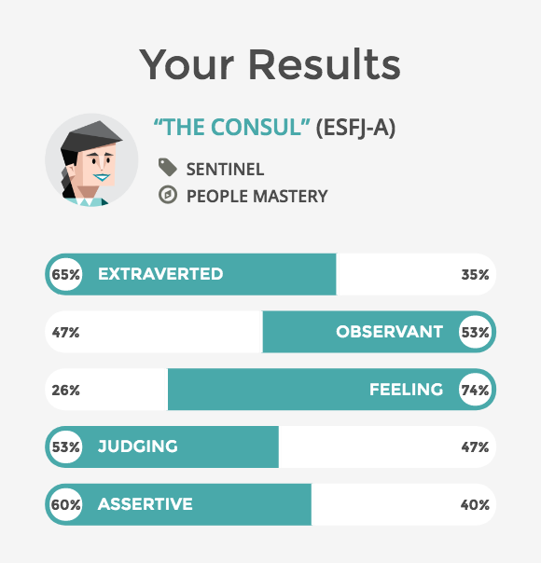*Source: The author*

### Extraversion/ Introversion

The E-I aspect shows the interaction with the surroundings, including people, things and activities within it. Extraverted individuals prefer to work in the group and get energized by social interaction, while introverts prefer to spend time working independently and their energy comes from the inner. (Fretwell, et al., 2013). An entrepreneur with extroverted personality type is willing to take the lead in many situations and can handle challenges in their path.

### Sensing/ Intuition

This index determines how individuals see and process information about outer world. Those with sensing personality type tend to look at and rely on the actual experience, proven results, practical matters; the way they approach changes is careful, incremental and critical (Hipple et al. (2001). The entrepreneur with this trait is highly practical, pragmatic and they focus on the actual things happening or had already happened around them.

### Thinking/ Feeling

This aspect address the way a person makes judgements and handle with emotions. People with the feeling trait tend to make decisions, which based on personal or social harmony and cooperation; they care about the feelings of others (Fretwell, et al., 2013). Entrepreneur with feeling personality type would prefer to cooperate rather than compete because for them, a decision that makes everyone feel happy is the powerful way to get the job done in the faster pace.

### Judging/ Perceiving

This factor determines in what way individuals approach to work, arrange and make decisions. Judging individuals are decisive, punctual, thorough, and have closed-minded attitude while those with perceiving personality are more open-minded (Fretwell, et al., 2013).

Entrepreneur with the judging trait would prefer to go with the plan than the flow, which is not suitable sometimes due to some unexpected situation might be happened.

### Self-evaluation conclusion

In general, the ESFJ is rated as a harmonious entrepreneur. They are highly organized, capable of seeing the trends and capitalizing on the opportunities. Also, with their organization skills, people will feel good about themselves and stay on the right track. As the result shown above, the author has the suitable personality to become an entrepreneur. However, she should see things in the bigger vision and be more open-minded.

## Business venture proposal

There have been 42 million luggage bags that went missing and never returned to their owner at the airport, which results in a big trouble for the travellers. (Vietnam Airlines, 2016). For this reason, it is not strange that many people tend to use smart tools attached to their luggage to secure and keep tract of their things. However, as these devices are not parts of the bag, they can get broken due to some impact damages during transport or come off easily and end up costing the users just a useless fortune.

Acknowledging these problems, the author has come up with an integrated solution, which is to provide travellers with an “EzTravel Smart Suitcase” (ESS) that involves ultimate features.

ESS is a technologically advanced suitcase, which can be connected to the user’s smartphone through an application. The user only needs to provide his/her travelling agenda and lets the application search for essential information from the airlines such as the time for departure, changes in flight schedule, flight’s length and some trip’s recommendations.

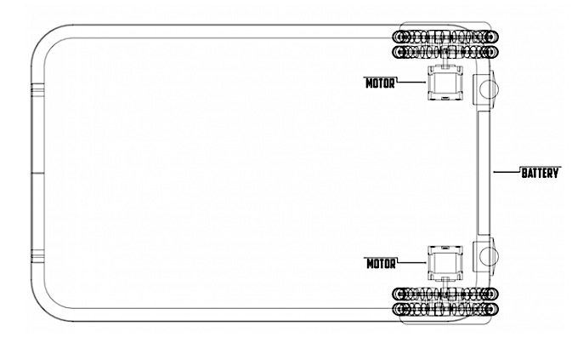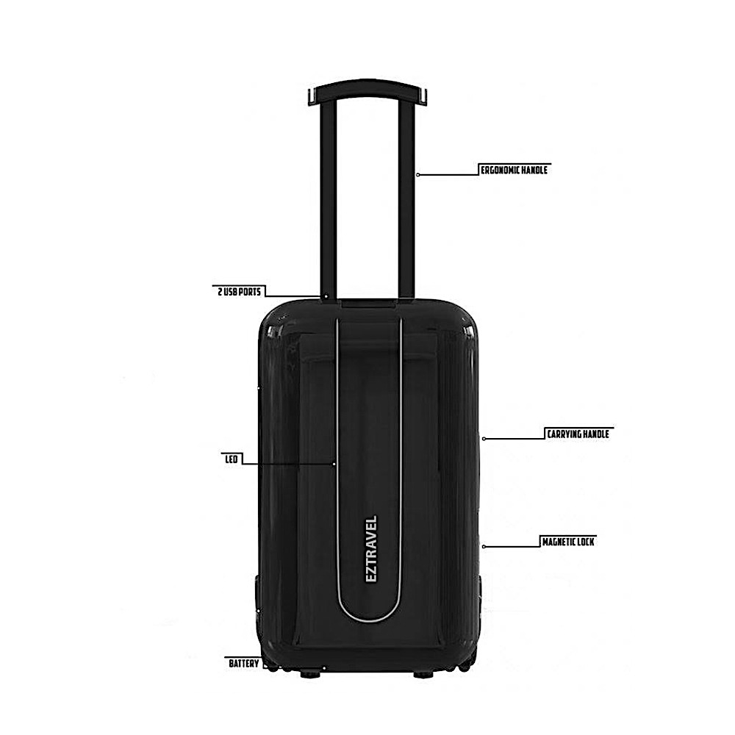Figure 2. The EzTravel designs

*Source: The author*

Apart from that, there are many preeminent functions integrated into the suitcase. The GPS chip inside each suitcase allows the travellers to keep track of their luggage through the application. Meanwhile, the high-tech locking system helps to prevent any strangers from intruding on the luggage’s privacy since it can only be unlocked with a password or the owner’s fingerprint.

Each ESS model is also equipped with an incorporated scale show the exact weight of the suitcase so that the user can adjust the weight in accordance with the airline’s regulation.

ESS model’s battery can last up to 100 hours and the battery level will be identified by the colour of LED lighting system of which green stands for 100% and red is a sign for low battery below 20%. The battery can also be used as a charger for the user’s other electronic devices. Useful as they are, these built-in parts account for only 2% of the capacity.

For now, ESS models come in three sizes, which are respectively carry-on, medium and large.

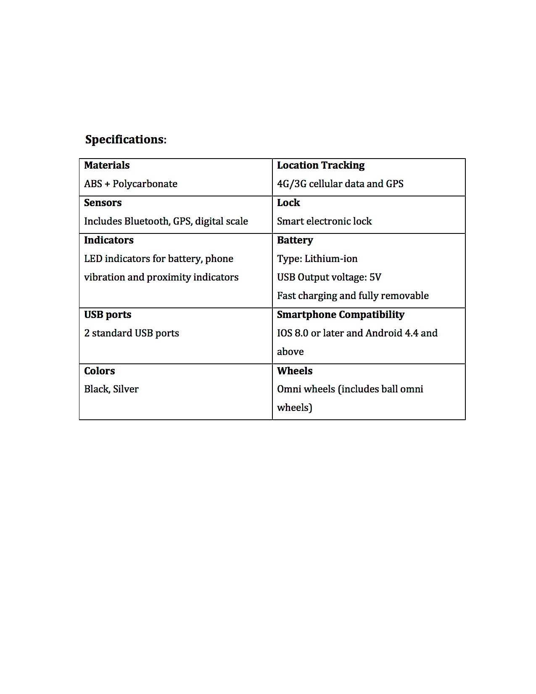Figure 3. Specifications of the EzTravel smart suitcase

*Source: The author*

## Market research

The main target groups are business and leisure travellers, who tend to be both males and females, have average income above VND 10 millions and regularly travel. The wages of workers doing high-skilled jobs in Vietnam in 2017 is VND 11.4 millions/month, which accounts for 23.5% population. (TradingEconomics.com)

After disseminate the Concept Statement, the author conducted a Buying Intention Survey (appendix 1) with 100 responds from travellers at International Noi Bai Airport, Hanoi, Vietnam in order to know how the potential customers react to the EzTravel smart suitcase More than 80% of the males were interested in the product as it related to the technological item. The author summarized the opportunity to be likely use by 61% favorable, which fulfills the desirability, demands and feasibility in commercial market.

Figure 4. Percentage of travellers willing to buy ESS

*Source: The author*

To come up with an efficient and decisive marketing strategy so that a certain product can successfully penetrate the market, the marketing-mix is likely to be a helpful analysis tool for entrepreneurs (Goi, 2009). Therefore, the author has utilized the marketing-mix to identify the potentials that ESS has in order to gain its market share.

Figure 5. The Marketing Mix

**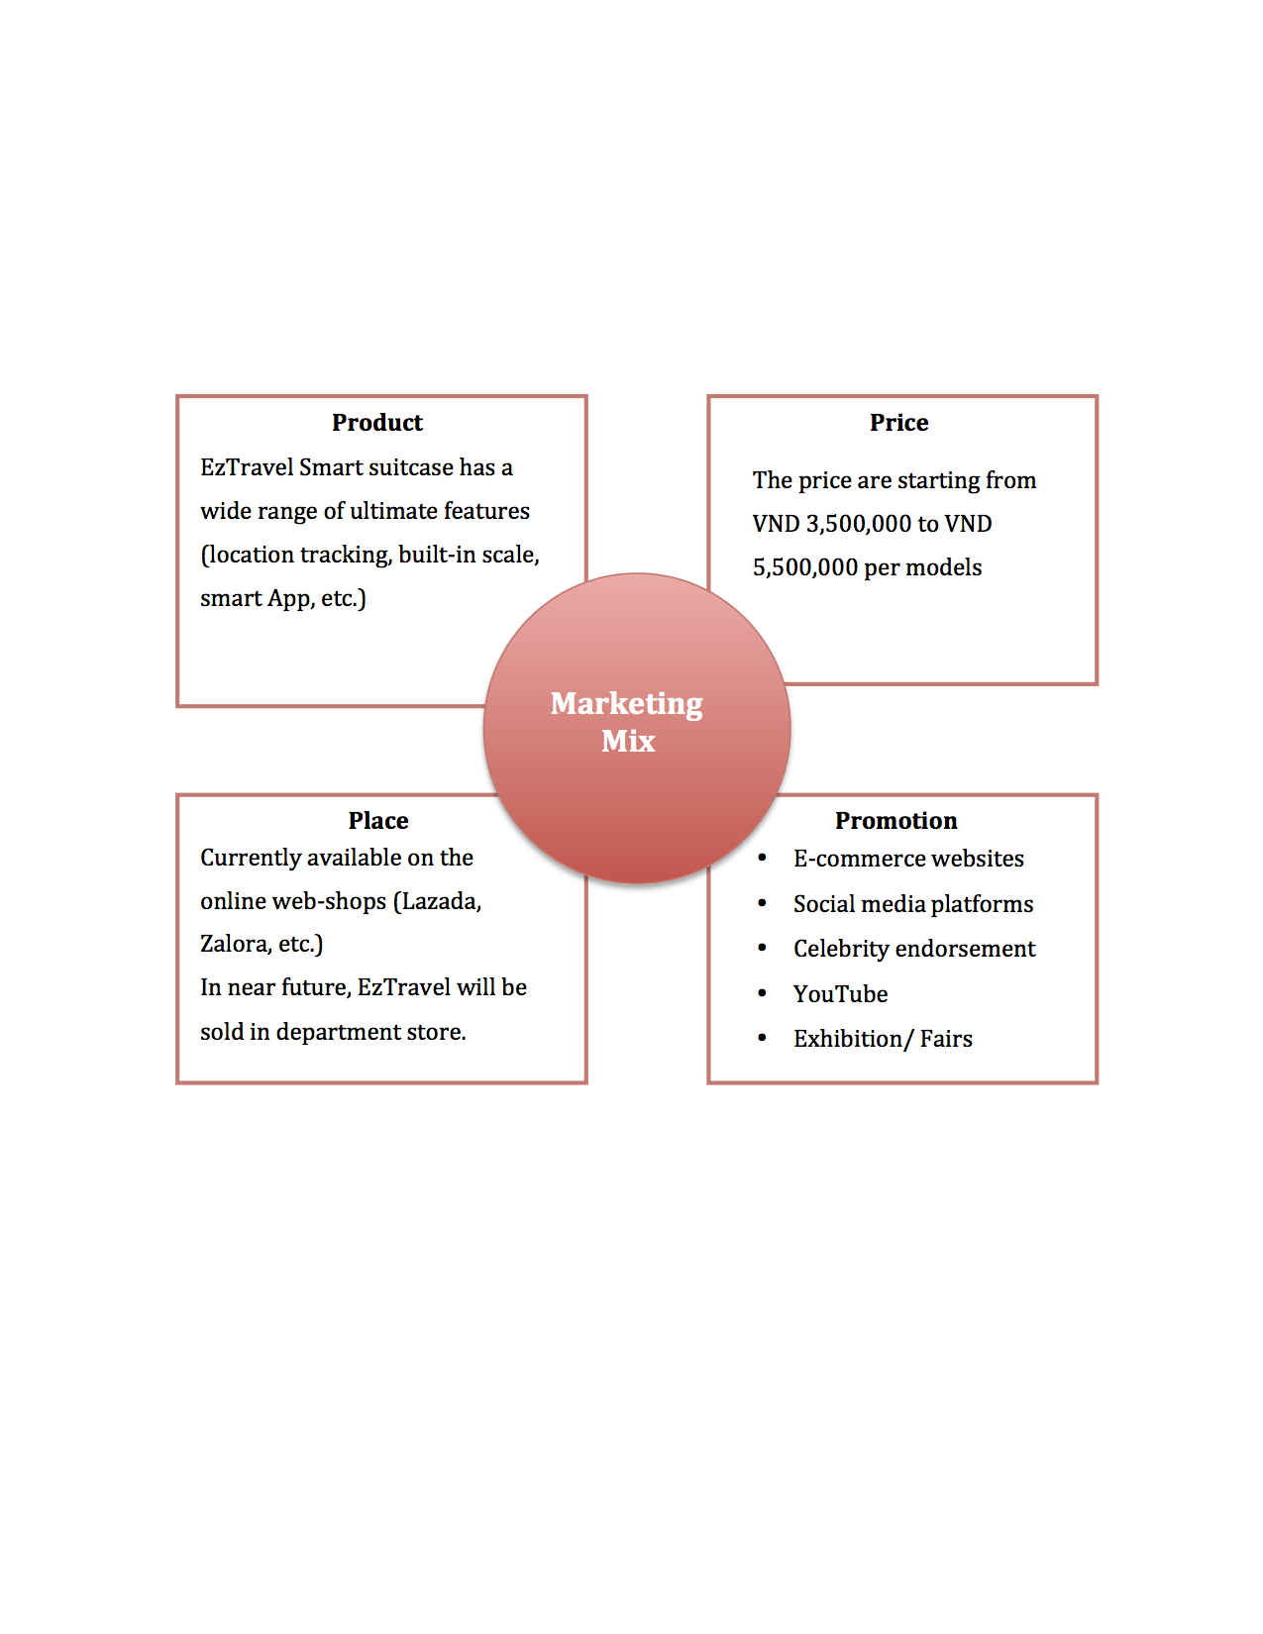***Source: The author*

## Industry analysis

In addition to do market research to understand more about the position of a product, it is suggested that entrepreneurs should take industry analysis into consideration as it helps determine the possible obstacles that a new business may face up with. Thus, the entrepreneur can foresee the potential profitability of a product based on whether the cost of market penetration is worthy and the product can secure its stability or not (Porter, 1988).

For this reason, an analysis on the industry of smart suitcase has been done by applying the five forces model of Porter (Bergen, et al., 2002), this imitation can provide an accurate picture of the business environment and competition among rivals in the same industry (figure 6).

Figure 6. The 5 forces model of Porter

*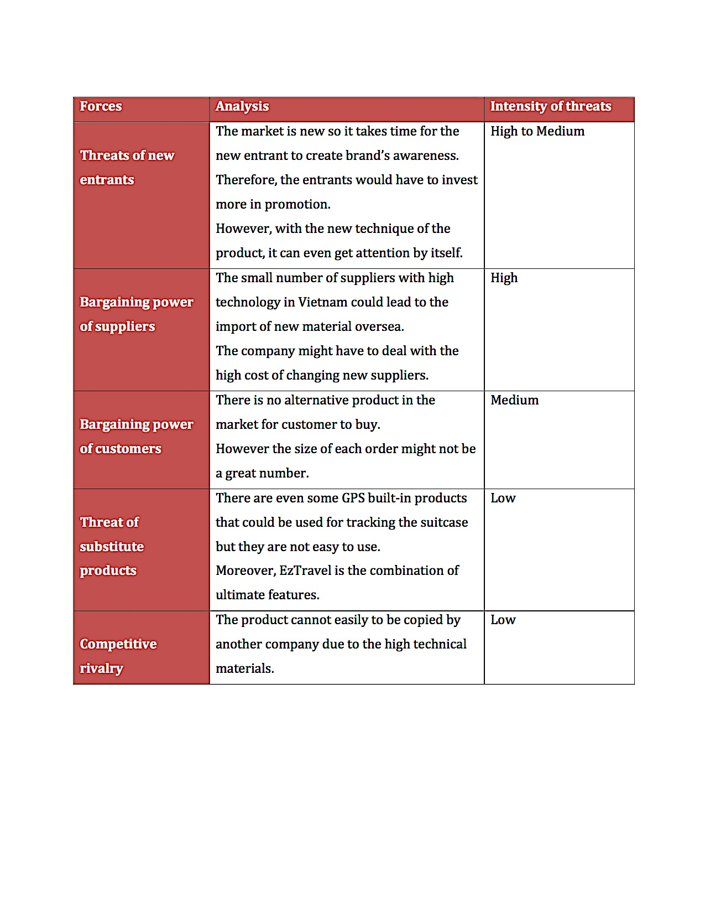Source: The author*

Since ESS is a new type of product, its direct rivals are currently not available and therefore it is impossible to evaluate them. However, it is noticeable that substitute products mentioned in the Porter’s model can become direct opponents, especially devices such as GPS tracking tools since Taiwanese models like A9 Plus, A1 Mini or T1 are likely to occupy a certain market share. Nevertheless, since each device has its own function, it is quite time-consuming for the users to affix all of them to their bags.

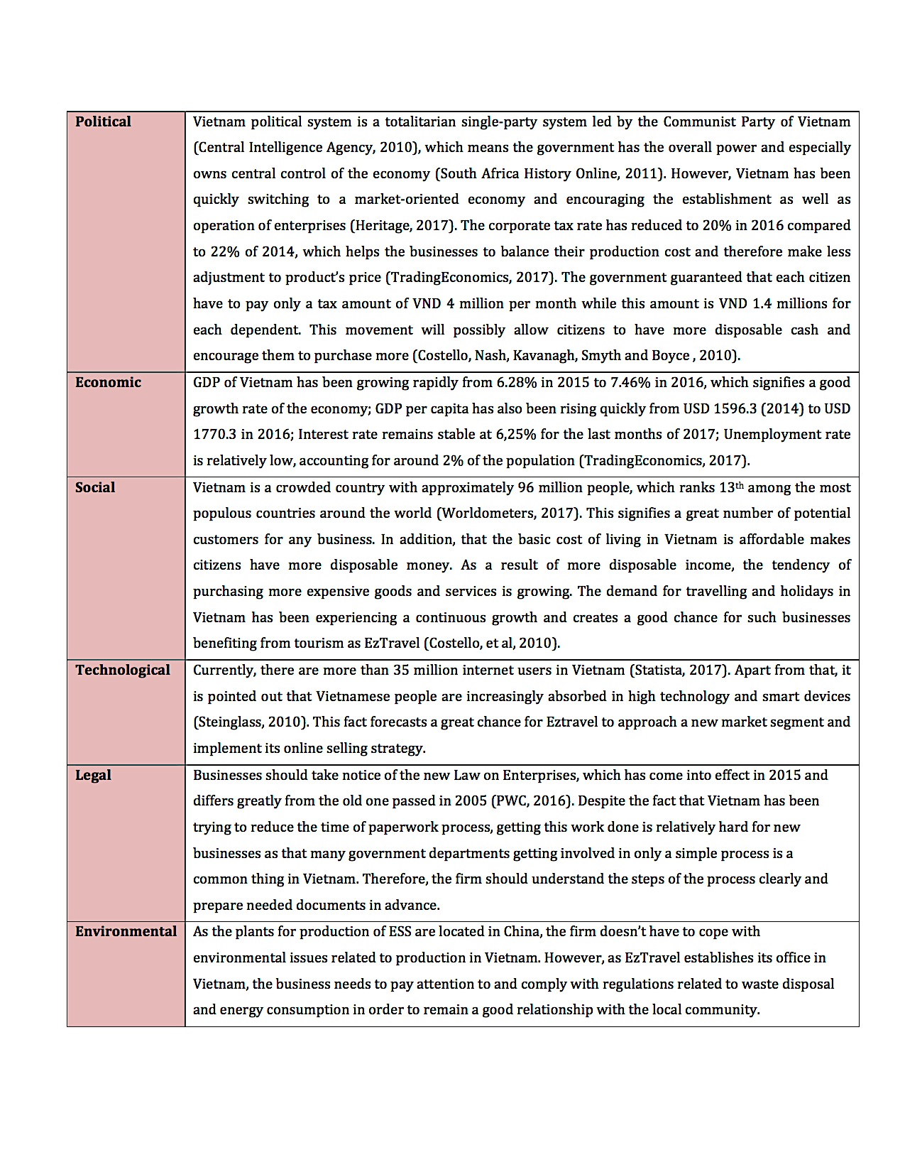Figure 7. PESTEL analysis

*Source: The author*

A business is affected not only by internal elements but also by the external business environment in which it develops. Therefore, the external business environment for ESS, which is Vietnam, was analyzed by PESTEL to have deeper understandings about its advantages and drawbacks.

## Technical feasibility

In order to develop the operation, technical feasibility promises a powerful instrument of analyzing (Bienkowski, M., 1995) .

It may be a dead end for entrepreneurs to violate regulations related to patent (Graham et al., 2009) as they can easily lose their newly gained position in the market when bigger investors decide to provide more capital. EzTravel is still an attainable trademark in Vietnam according to NOIP (National Office of Intellectual Property of Vietnam).

The production of ESS models will take place in China since ESS’s components are also made in this country and the cost of assembly is cheaper than that in neighboring countries (Jayaraman, 2010). Therefore, the author might use the oversea express shipping, such as FedEx for cheap cost but low weight of goods; then store the products in a warehouse, which needs to be rented. For delivering products, it would help the business to save more by using the ViettelPost or ExpressPost service.

The author will hire staff for customer services, sales and marketing department to accelerate the consuming of the products. The workforce therefore must be well trained in communication skills and technological skills. There will not be any problems to hire those high skilled employees since the author is proved in the Self-analysis part as a harmonious entrepreneur, who can connect people and create a good working environment.

## Financial feasibility

The firm can get access to financial resources in different ways; however relying on an investor is the most common approach (Čalopa, et al., 2014). Businesses need to guarantee a balanced portfolio in order to attract investor as he/she will evaluate it and decide whether his/her investment can result in a reward (Goldberg and Mahmoud, 2013).

The business can receive funding from investment firm - VIISA (Vietnam Innovative Startup Accelerator), which is interested in developing project related high technology. The author aim to acquire VND 5 billions from external investor and pay an interest rate of 3%.

The EzTravel has plenty of fundamental expenses for advertising and human resources for five-year prediction (table 1).

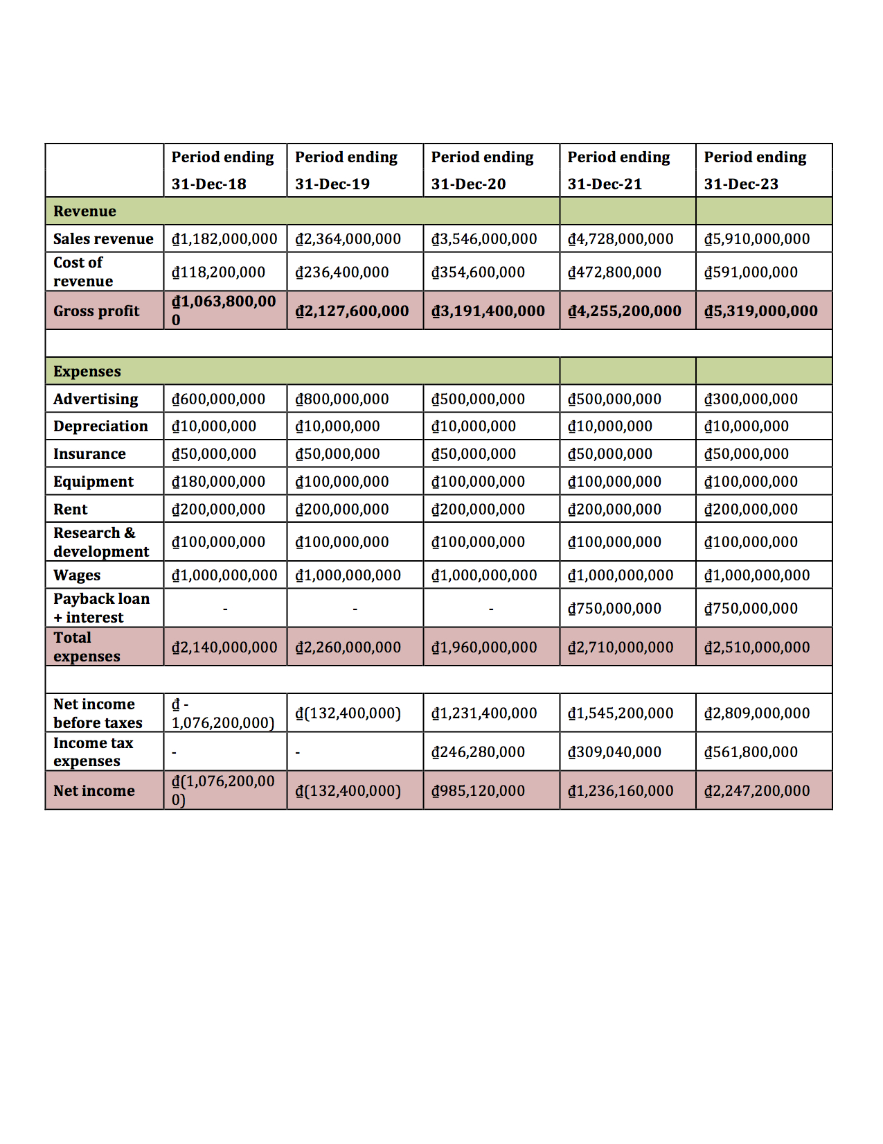Table 1. Income statement from 2018 to 2020

*Source: The author*

The profit is predicted to be achieving after two years of advertising. The author will pay back a loan of VND 5 billions at interest rate of 3% starting from the third year in consideration of stabilizing the business in the first two years. In Vietnam, the company has to pay the standard corporate tax rate of 20% (Thomas, 2017), so that’s the amount written in table 1 after the profit has gained.

# Scenario versions

The author has come up with possibility of risks that the business may face up with in its first five years of operation and also provide appropriate solutions to these foreseen problems.

**The inability of investors to provide full investment or a complete investment withdrawal**

In this situation, the business needs to negotiate with the current investor or seeks for another investment source. The firm can rely on crowd funding with a condition that it has to prove its profitability, which is normally the possibility of production, to the consumers before getting the fund (Ordanini et al., 2011). Therefore, the company should make sure that the manufacturing process functions smoothly.

**The issue of illegal replication**

In this situation, the entrepreneur should issue the patent for his or her product right away as the product is the key to a business’ success. In a worse scenario that other firms have already gained the market share by this illegal act, the start-up should pay attention to improve its research and development to introduce better products and remain its pioneer position.

**The problems in manufacturing process**

Having an alternative manufacturer is necessarily as the trouble with the primary manufacturers does exist. The firm should also work on the price of the deal since the backup manufacturer can push the price up in case of emergency

# Scalability

A scalable business can have its revenues rising in a quicker pace compared to that of the equivalent cost base (Björkdahl and Holmén, 2013). It is the scalability that accounts for the business’ profitability as the factors costing the most in the business does not include manufacturing (table 1). More investments might need to be acquired in order to manage the business. There are a plenty of potential manufacturers for the author to make up her mind in China.

# Conclusion

The EzTravel Smart Suitcase is a high technological product that fits the market segment of business and leisure travellers with the income above VND 10 millions, and regularly travelling according to the BIS (appendix 1). Therefore, there would no disagreement for selling these at the starting price of VND 3.5 millions. It is admitted this is an attractive market with no direct rivals and it’s not easy for outsider to copy the product. As self-analysis, the author has appropriate traits to become an entrepreneur; however she needs to be aware of her weaknesses and try to solve them to the extend of become a successful businessperson.

# References

Abrams, N. D. (2011). Temperament and personality assessments: Tools for mediators?. *Dispute Resolution Journal*, 66(4), pp.56-74

Bause, K., Radimersky, A., Iwanicki, M. and Albers, A. (2014). Feasibility Studies in the Product Development Process. *Procedia CIRP*, [online] 21, pp.473-478. Available at: <http://www.sciencedirect.com/science/article/pii/S2212827114006684?via%3Dihub> [Accessed 3 Dec. 2017].

Bergen, M. and Peteraf, M. (2002). Competitor identification and competitor analysis: a broad-based managerial approach. *Managerial and Decision Economics*, [online] 23(4-5), pp.157-169. Available at: <http://assets.csom.umn.edu/assets/71542.pdf> [Accessed 6 Jun. 2017].

Bienkowski, M., 1995. Demonstrating the operational feasibility of new technologies: the ARPI

IFDs. *IEEE Expert*, 10(1), pp.27-33.

Čalopa, M., Horvat, J. and Lalić, M. (2014). Analysis of financing sources for start-up companies. *Management*, 19(2), pp.19-44.

Central Intelligence Agency (2010) *The World Factbook - Vietnam*. [online] Available at: <https://www.cia.gov/library/publications/the-world-factbook/geos/vm.html> [Accessed 5 Dec. 2017]

Costello E., Nash T. , Kavanagh K., Smyth S., Boyce L. (2010). *International Marketing Environment Study of Vietnam*. [online] Available at: <https://eoinkcostello.files.wordpress.com/2015/01/global_marketing_and_competitiveness_assignment.pdf> [Accessed 5 Dec. 2017]

Fretwell, C., Lewis, C. and Hannay, M. (2013). Myers-Briggs Type Indicator, A/B Personality Types, and Locus of Control: Where Do They Intersect?. *American Journal of Management*, [online] 13(3), pp.57-66. Available at: <http://www.na-businesspress.com/AJM/FretwellCE_Web13_3_.pdf> [Accessed 2 Dec. 2017].

Graham, S., Merges, R., Samuelson, P. and Sichelman, T. (2009). High Technology Entrepreneurs and the Patent System: Results of the 2008 Berkeley Patent Survey. *SSRN Electronic Journal*, [online] 24(4), pp.1255-1328. Available at: <http://scholarship.law.berkeley.edu/cgi/viewcontent.cgi?article=1034&context=btlj> [Accessed 4 Dec. 2017].

Goi, C. (2009). A Review of Marketing Mix: 4Ps or More?. *International Journal of Marketing Studies*, [online] 1(1), pp.2-15. Available at: <http://www.ccsenet.org/journal/index.php/ijms/article/view/97/1552> [Accessed 5 Dec. 2017].

Goldberg, L. and Mahmoud, O. (2013). Risk without return. *The Journal of Investment Strategies*, [online] 2(2), pp.111-120. Available at: https://arxiv.org/pdf/1307.0114.pdf [Accessed 6 Dec. 2017].

Heritage. (2017). *2017 Index of Economic Freedom – Vietnam*. [online] Heritage. Available from: <http://www.heritage.org/index/country/vietnam> [Accessed 5 Dec. 2017]

Hipple, J.; Harde, D.; Wilson, S. A.; Michalski, J. 2001. Can corporate innovation champions survive? *Chemical Innovation*, November, pp.14–22.

Jayaraman, K. (2010). Doing Business in China: A Risk Analysis. *Journal of Emerging Knowledge on Emerging Markets*, [online] 1(1), pp.54-62. Available at: <http://digitalcommons.kennesaw.edu/cgi/viewcontent.cgi?article=1006&context=jekem> [Accessed 5 Dec. 2017].

Ordanini, A., Miceli, L., Pizzetti, M. and Parasuraman, A. (2011). Crowd‐funding: transforming customers into investors through innovative service platforms. *Journal of Service Management*, [online] 22(4), pp.443-470. Available at: <http://www.emeraldinsight.com/doi/abs/10.1108/09564231111155079> [Accessed 7 Dec. 2017].

Porter, M. (1988). Competition in Global Industries. *Journal of Marketing*, 52(1), p.150.

PWC. (2016). *Doing business in Vietnam*. [online] Available at: <https://www.pwc.com/vn/en/publications/2016/pwc-vietnam-doing-business-guide-2016.pdf> [Accessed Dec 6. 2017]

South Africa History Online. (2011). *Differences between Capitalism & Communism and why did it start in Russia.* [online] Available at: <http://www.sahistory.org.za/article/differences-between-capitalism-communism-and-why-did-it-start-russia> [Accessed Dec 3. 2017]

Statista. (2017). *Number of Internet users in Vietnam from 2015 to 2022 (in millions).* [online] Available at: <https://www.statista.com/statistics/369732/internet-users-vietnam/> [Accessed Dec 4. 2017]

Steinglass, M. (2010). *Vietnamese go gadget shopping*, Financial Times (London, UK), p.6.

Thomas, M. (2017). International tax*. Vietnam Highlights 2017.* [online] Available at: <https://www2.deloitte.com/content/dam/Deloitte/global/Documents/Tax/dttl-tax-vietnamhighlights-2017.pdf> [Accessed 2 Dec. 2017]

TradingEconomics.com (2017). *Vietnam wages high skilled.* [online] Available at:

<https://tradingeconomics.com/vietnam/wages-high-skilled> [Accessed 2 Dec. 2017]

TradingEconomics.com (2017). *Vietnam Corporate Tax Rate*. [online]. TradingEconomics. Available at: [https://TradingEconomics/vietnam/corporate-tax-rate](https://tradingeconomics.com/vietnam/corporate-tax-rate) [Accessed 2 Dec. 2017]

TradingEconomics.com. (2017). *Vietnam GDP*. [online]. TradingEconomics. Available from: <https://tradingeconomics.com/vietnam/gdp> [Accessed 2 Dec. 2017]

TradingEconomics.com (2017). *Vietnam GDP per capita.* [online] Available at:

<https://tradingeconomics.com/vietnam/gdp-per-capita> [Accessed 2 Dec. 2017]

TradingEconomics.com (2017). *Vietnam Interest Rate.* [online] Available at:

<https://tradingeconomics.com/vietnam/interest-rate> [Accessed 5 Dec. 2017]

TradingEconomics.com (2017). *Unemployment Rate.* [online] Available at:

<https://tradingeconomics.com/vietnam/unemployment-rate> [Accessed 2 Dec. 2017]

VietnamAirlines.Travel. (2017) *Avoiding lost luggage Vietnam airlines.* [online] Available at:

<https://www.vietnamairlines.travel/air-vietnam-tips-on-avoiding-lost-luggages.vietnam-airlines> [Accessed 5 Dec. 2017]

Worldometers.info (2017*). Vietnam Population*. [online] Available at: <http://www.worldometers.info/world-population/vietnam-population/> [Accessed 4 Dec. 2017]

# Appendices

## Appendix 1: Buying Intention Survey

## Mactonish:Users:macbookvietnet:Downloads:bis.jpg

## Appendix 2: SWOT analysis

